**IDEXX DISCREPANCY AUTOMATIC PACKAGE COUNT UPDATE DELIVERY**

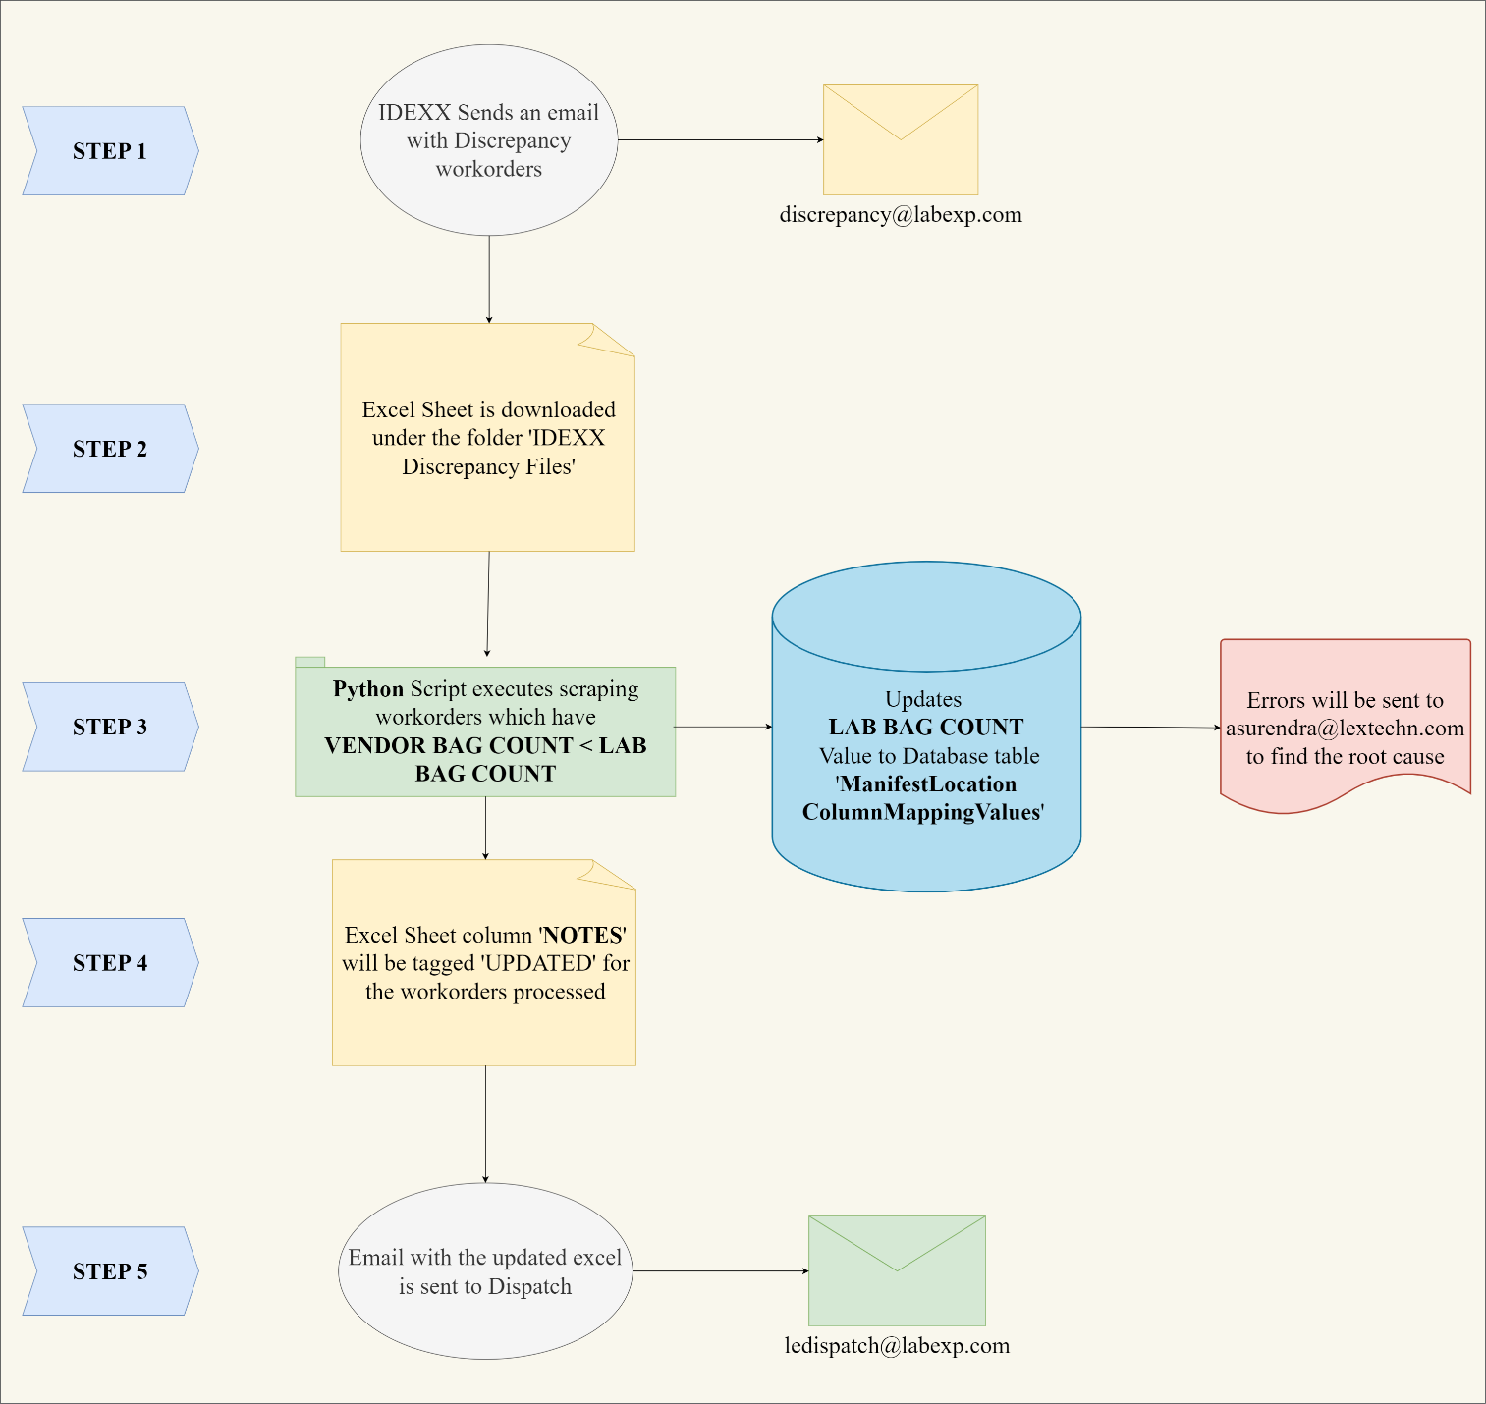

**Requirements from IDEXX:**

1. Emails must be sent to [discrepancy@labexp.com](mailto:discrepancy@labexp.com) with the subject containing the word 'Discrepancy' or 'Discrepancies' it can have started or tailing any words.

2. Any new discrepancy workorders must be presented in a new email with the latest discrepancy workorders in the latest(right-most) tab.

3. All Discrepancy workorders must be in the excel sheet and not in the body of an email. The required columns for the script to process (should follow the same naming convention):

a. Workorder

b. Vendor Bag Count

c. Lab Bag Count

d. Notes

If any of the above is not followed, the script/workflow fails to execute to update the package counts automatically.

**Dispatch**